ID | RAW VALUE | RATE CURVE
1 |  | 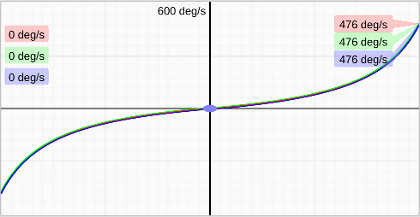
   | RC Rate | Super Rate | Expo
  R | 0.50 | 0.80 | 0.00
  P | 0.50 | 0.80 | 0.00
  Y | 0.50 | 0.80 | 0.00
2 |  | 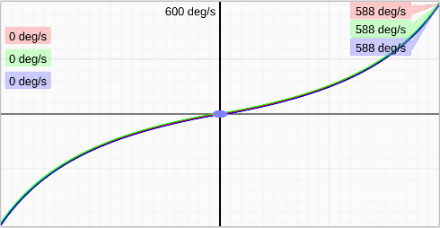
   | RC Rate | Super Rate | Expo
  R | 1.03 | 0.66 | 0.00
  P | 1.03 | 0.66 | 0.00
  Y | 1.03 | 0.66 | 0.00
3 |  | 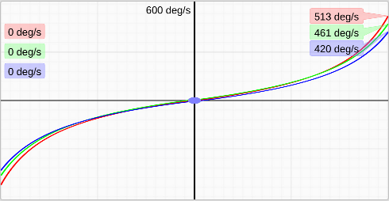
   | RC Rate | Super Rate | Expo
  R | 0.91 | 0.66 | 0.15
  P | 0.91 | 0.62 | 0.15
  Y | 0.85 | 0.61 | 0.15
4 |  | 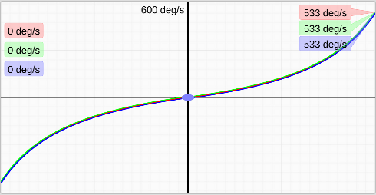
   | RC Rate | Super Rate | Expo
  R | 0.80 | 0.71 | 0.00
  P | 0.80 | 0.71 | 0.00
  Y | 0.80 | 0.71 | 0.00
5 |  | 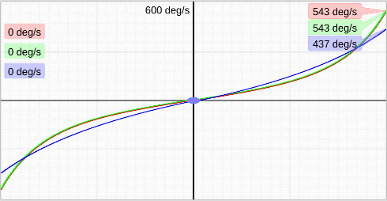
   | RC Rate | Super Rate | Expo
  R | 1.75 | 0.38 | 0.47
  P | 1.75 | 0.38 | 0.47
  Y | 1.27 | 0.43 | 0.04
6 |  | 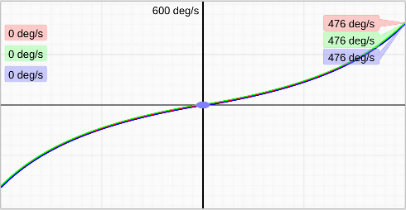
   | RC Rate | Super Rate | Expo
  R | 1.00 | 0.59 | 0.01
  P | 1.00 | 0.59 | 0.01
  Y | 1.00 | 0.59 | 0.01



